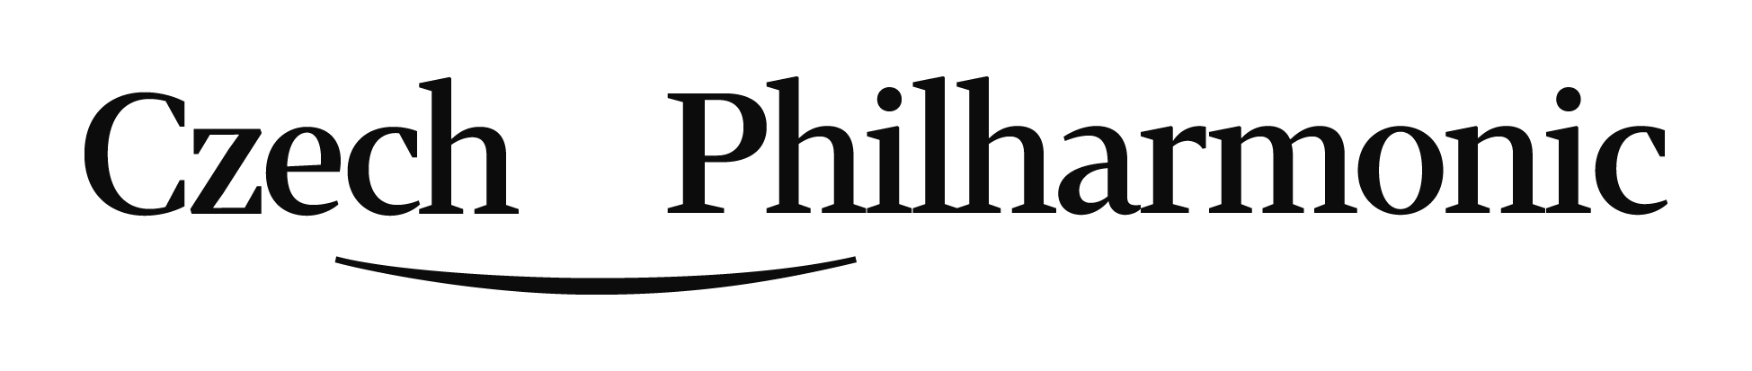
Application form - - position of 2nd trombone
(with a perspective of 1st trombone starting 2021-22)
(Prague - Rudolfinum June 12, 2020)
Personal data
Surname
Given name
Date of Birth
Email
Phone No.
Home address
incl. ZIP, country

Please, hereafter submit data in a very brief way only (five most important items of each).

Education / Qualifications / Teachers:
max. 5 most important items

Your participation in competitions / master classes:
max. 5 most important items
Your work / orchestral experience:
max. 5 most important items

Let us know your chosen piece in 2nd round:

Do you ask for our piano accompanist or you will bring yours?:
….. Yes, I need to be provided with a piano accompaniment.
….. No, I have my own accompanist.
IMPORTANT:
Post your recording on the YouTube and let us know a link and password to access.
Then, please, submit filled application form, structured/itemized CV,
your photo, copy of your diploma and access link and password
to the requested recording on YouTube to:
audition@czechphilharmonic.cz

Application closing date is APRIL 30, 2020.
FORM ENG v200203

