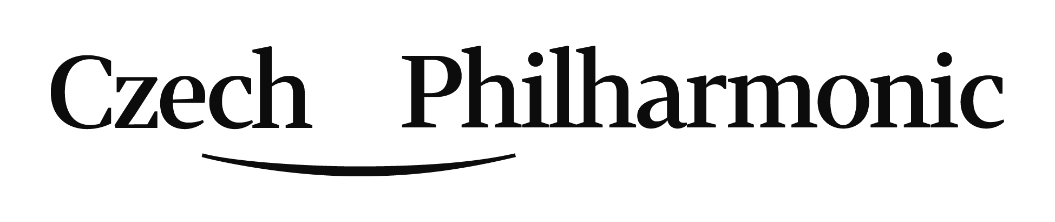
Application form - Audition for the position of
3rd trombone with duty of basstrombone
(Prague Rudolfinum - June 21, 2019)
Personal data
Surname
Given name
Date of Birth
Email
Phone No.
Home address
incl. ZIP, country

Please, hereafter submit data in a very brief way only (five most important items of each).
Education / Qualifications / Teachers:
max. 5 most important items

Your participation in competitions / master classes:
max. 5 most important items
Your work / orchestral experience:
max. 5 most important items

Let us know your request of our piano accompanist or you will bring yours:
….. Yes, I need to be provided with a piano accompaniment.
….. No, I have my own accompanist.
IMPORTANT:
Your recording formate is to be playable with the operational system Windows (i.e. AVI, MPG, MP4, MOV etc.) definition level 1280 x 720.
Send it via https://wetransfer.com or www.uschovna.cz/en/.

Please, submit this application form, structured itemized CV, your photo, copy of your diploma and the requested recording to:
audition@czechphilharmonic.cz
Application closing date is May 10, 2019.
(FORM ENG v190124)

