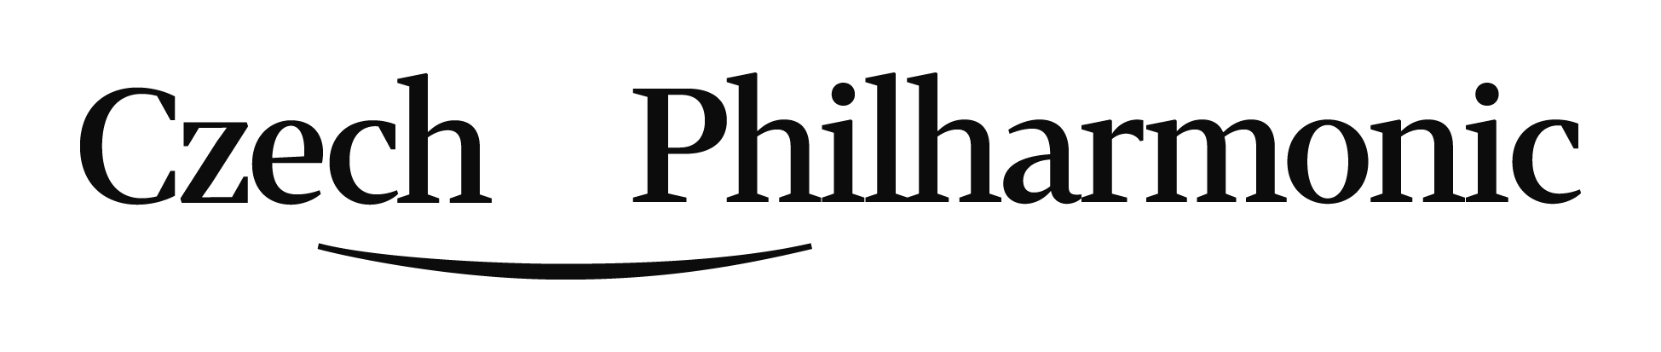
Application form - Audition for the position of
1st Flute
Personal data
Surname
Given name
Email
Phone No.
Home address
incl. ZIP
Country / State

Please, hereafter submit data in a very brief way only (five most important items of each.
Education / Qualifications / Teachers:

Your participation in competitions / master classes:

Your work / orchestral experience:

Please, tell us your chosen piece for the second round:

Let us know your request of our piano accompanist or you will bring yours:

….. Yes, I need to be provided with a piano accompaniment.
….. No, I have my own accompanist.

Please, attach your portrait photo and submit a copy of your diploma or certificate and send to: audition@czechphilharmonic.cz

