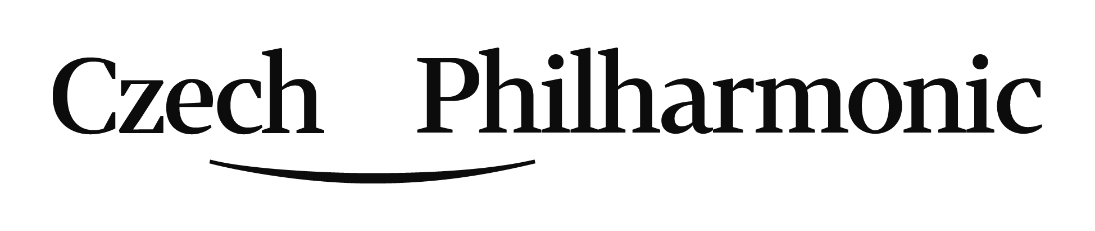
Application form - Audition for the position of the contrabassoon with the obligation of 2nd bassoon

PERSONAL DATA
SURNAME
GIVEN NAME
EMAIL
PHONE No.
HOME ADDRESS
ZIP CODE |  | STATE / COUNTRY

Please, hereafter submit data in a very brief way only.
EDUCATION / QUALIFICATIONS / TEACHERS:

YOUR PARTICIPATION IN IMPORTANT COMPETITIONS / MASTER CLASSES:

YOUR WORK / ORCHESTRAL EXPERIENCE:

LET US KNOW YOUR REQUEST OF OUR PIANO ACCOMPANIST OR YOU WILL BRING YOURS:
….. Yes, I need to be provided with a piano accompaniment.
….. No, I have my own accompanist.

Please, attach your portrait photo and submit a copy of your diploma or certificate and send to: audition@czechphilharmonic.cz
or by mail:
Czech Philharmonic „AUDITION“
Rudolfinum, Alšovo nábřeží 79/12, CZ-11000 Praha 1, Czech Republic

